Improving Usability of Conversational AI through Context-Aware Re-finding Interaction
Team 2 (HyeokJae Cho, Hyunji Jeong, Boyoung Kwon, Suyoung Kwon, Jieun Woo)

1. INTRODUCTION

1.1. Background
LLM-based conversational interfaces are increasingly used not only for one-time question answering but also for extended tasks such as information exploration, writing, coding, and learning. Through repeated interactions, users accumulate large volumes of conversation histories that function as personal work resources or knowledge archives. As the use of conversational AI becomes more continuous and task-oriented, revisiting prior conversations becomes a meaningful part of ongoing work. However, how users return to and make use of those past conversation records has not been sufficiently examined in HCI research, which has more often focused on prompting strategies or response quality.

1.2. The Gap: Current vs. Desired Interaction
To identify a concrete usability problem in conversational AI, we analyzed how current AI services support users’ re-finding of past conversations. Our analysis focused on the mismatch between how users remember prior interactions and how existing services make those interactions accessible. In particular, we examined whether current services support both direct retrieval based on exact recall and progressive narrowing based on partial contextual cues. In this section, concepts such as teleporting and orienteering are used only as an analytic lens for interpreting observed interaction patterns across services, rather than as the main theoretical focus.

1.2.1. User Expectations
Users perceive their conversation archives as a large knowledge repository and expect to be able to instantly recall specific ‘anchor conversations’ as needed. These expectations can be further differentiated according to the user’s context and the vividness of their memory, as follows.
A. Situational Dimensions of Re-finding
The context in which a user seeks an anchor conversation varies along dimensions of scope and time.
- Temporal scope (Recency vs. History): Ranges from short-term searches to verify the key summary of a just-completed conversation, to long-term searches to recover ideas from days or months ago.
- Breadth of search (Intra-thread vs. Inter-thread): Divided into cases where the user searches for an anchor within a specific active thread and cases where the user cannot remember which thread it was and must search across the entire history.
B. Cognitive Search Modes
The manner in which users search for anchor conversations can be categorized into two search strategies as defined by Teevan et al. (2004).
- Teleporting mode: A state in which the user precisely remembers a specific keyword or the content of an answer and attempts to jump immediately to the anchor conversation. Although the user has a clear goal, current interfaces have a high probability of failure when an exact search term is unavailable.
- Orienteering mode: A state in which memory of the anchor conversation is vague, and the user approaches it gradually using surrounding context and partial cues. Instead of a single leap, the user expects to take small steps to narrow down the target, which reduces cognitive load in situations where it is difficult to fully specify the search intent.
C. Desired Interaction Goals
The experience that users ultimately desire in AI services is to reach the anchor conversation immediately without having to backtrack through timestamps or engage in meaningless scrolling. Users want the system to bridge the gap between the cues in their memory and the target information without error.

1.2.2. Current AI Service Limitations
Current AI services exhibit three major limitations in efficiently supporting users’ re-finding of past anchor conversations.
A. Limited Search Scope & Logic
Current conversational tools confine their search scope to specific data domains or rely on incomplete metadata, frustrating teleporting attempts of the users.
- Domain isolation: Cursor provides powerful in-file code search, yet excludes conversation logs containing critical design decisions and logic explanations from its search index. Users experience the contradiction of having to revert to manual browsing to find the context behind their code. Similarly, Moonlight supports keyword search within literature but not within conversation logs.
- Metadata dependence: Copilot, Claude, and Claude Code search only summarized titles or the first question, rather than the full body of the conversation. This creates a severe mismatch between the specific keywords users remember and the search scope the system provides.
- Deficient search logic: Copilot's search function uses character-level matching. Such simplistic search logic over-exposes meaningless results, significantly degrading search precision.
B. Navigational Barriers & Cognitive Friction
The linear structure, which simply lists conversation logs in chronological order, hinders users’ orienteering approach of tracing context to reach their target.
- Forced scrolling: In ChatGPT, Gemini, and Cursor, the absence of in-conversation search forces users to rely on the browser’s Cmd+F as a workaround, creating a ‘scroll-and-skim’ loop of reviewing message bubbles one by one.
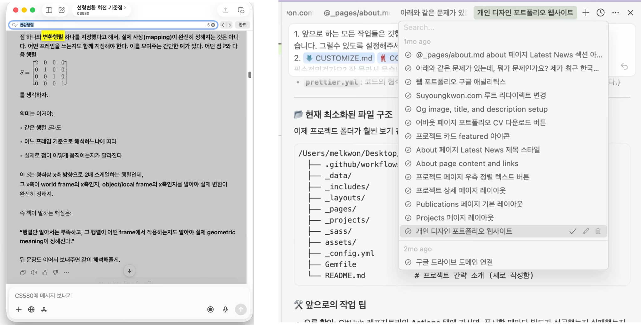
Figure 1. In GPT (left) and Cursor (right), users rely on browser-level Cmd+F as a workaround for the lack of in-conversation search.
- Focus failure: In Claude, selecting a specific thread from search results does not automatically navigate to the answer’s location but instead moves the user to the end of the session, maximizing ‘cognitive friction’ during re-finding.
- Ambiguous temporal cues: In Claude, broad time range labels (e.g., 1 year ago) fail to provide sufficient cues for users to match their internal sense of timing with the conversation log. 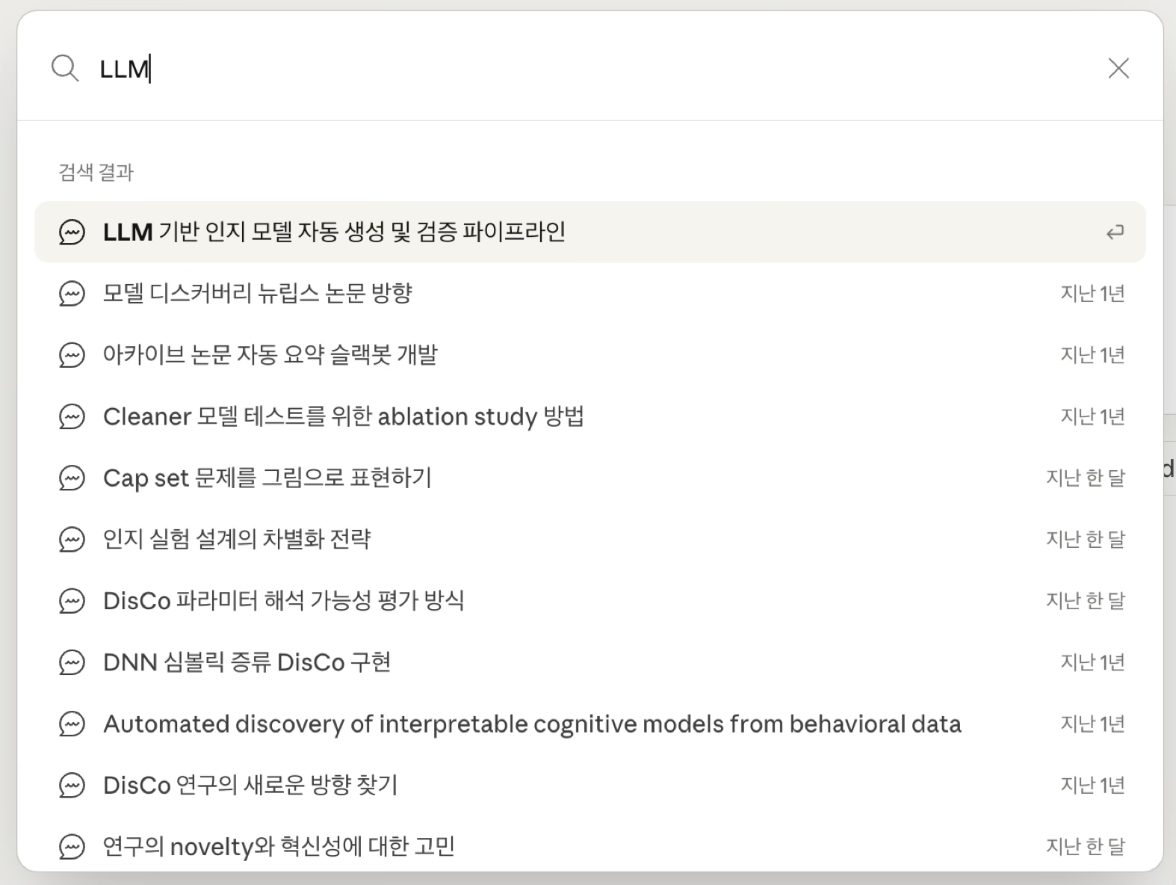
Figure 2. Ambiguous temporal cues in Claude search results.

C. Contextual Fragmentation
Features that manage information separately can paradoxically sever the connection to the context in which that information was generated.
- Loss of context: In NotebookLM, answers can be saved as notes, but the link to the original question and logical flow is lost, diminishing the information's usefulness upon revisitation.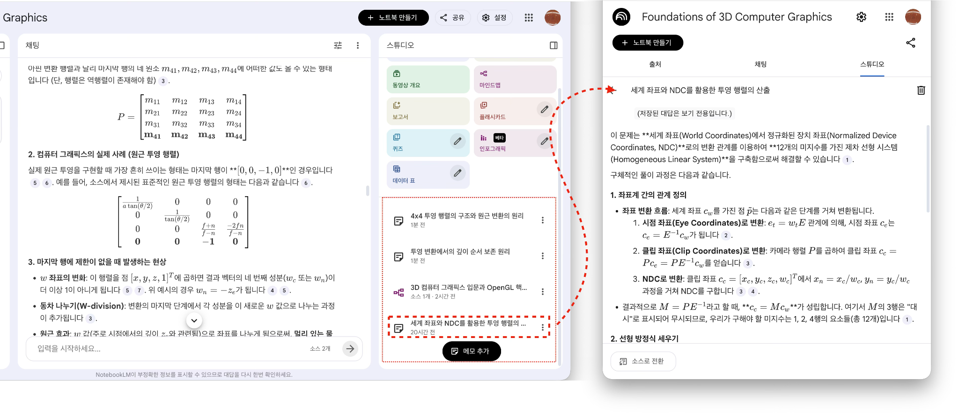
Figure 3. Loss of context in NotebookLM’s saved notes.

- Interaction interference: Moonlight conflicts with the browser’s native search shortcuts, preventing users from maintaining their familiar navigation habits.
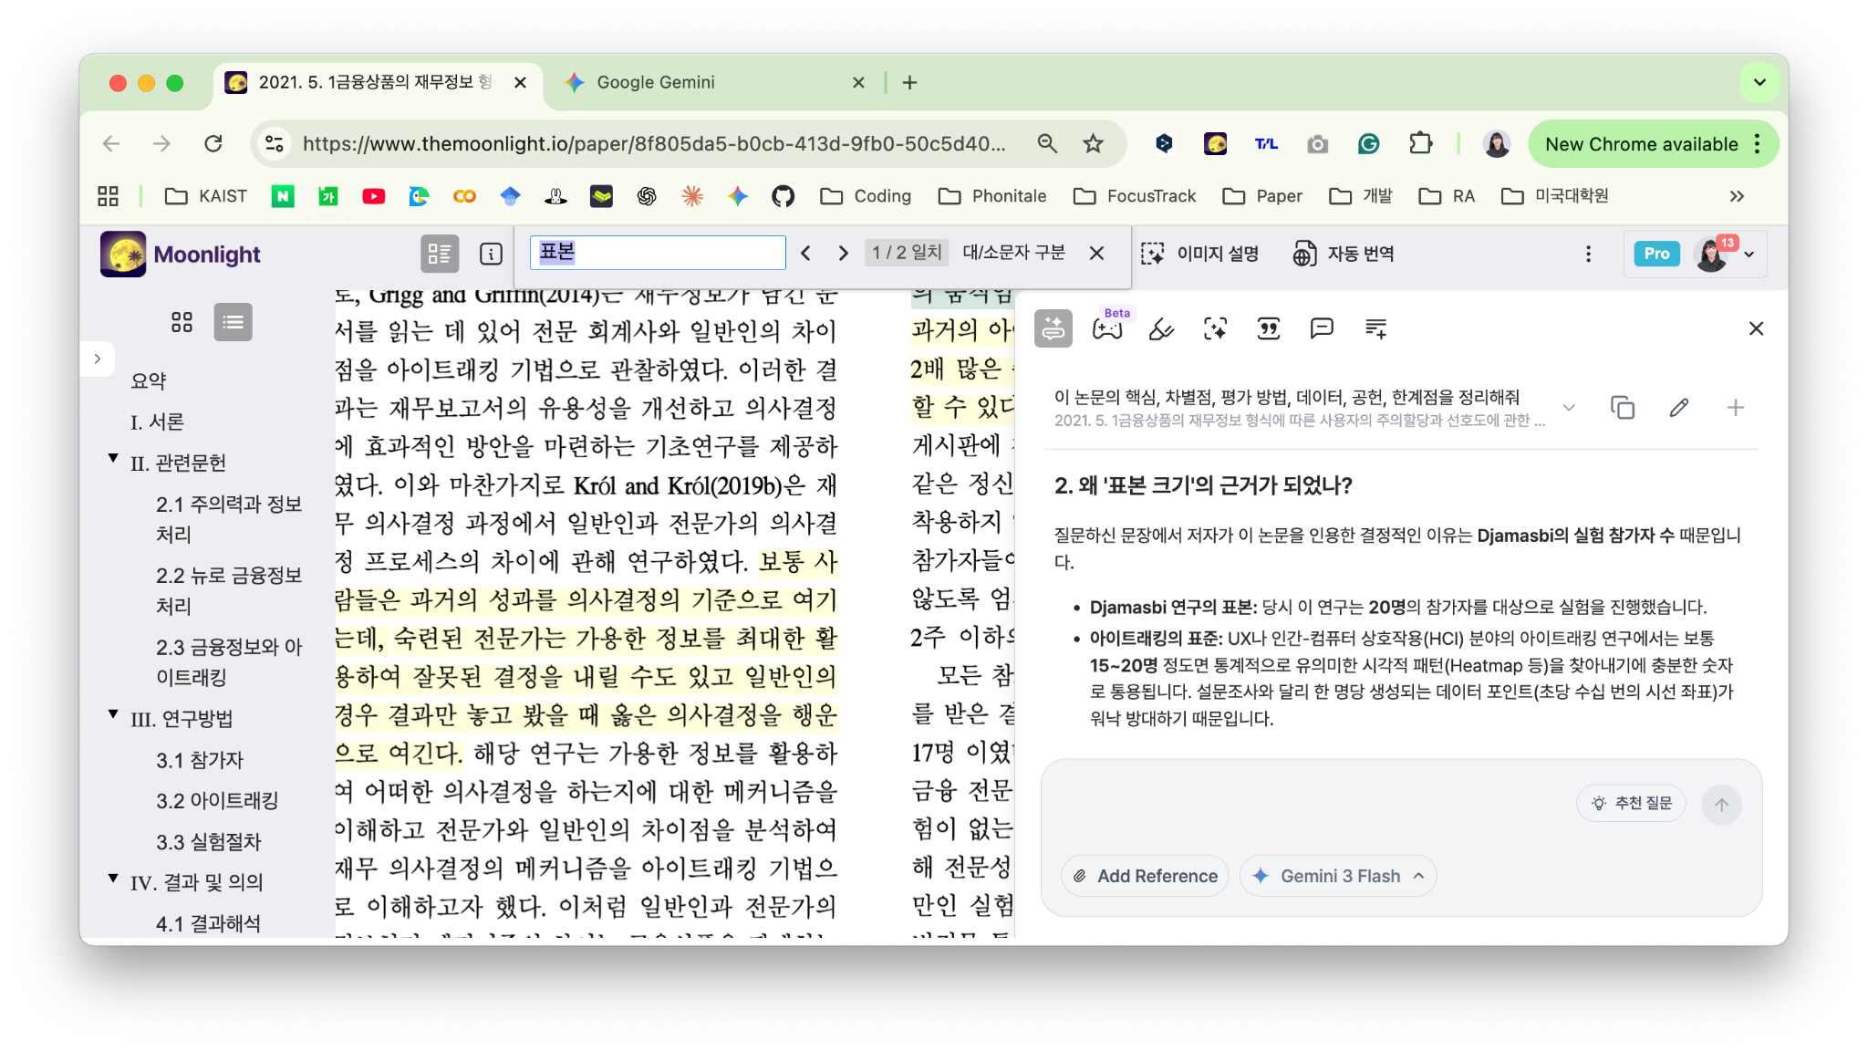
Figure 4. Moonlight’s interference with the browser’s native Cmd+F shortcut.

1.3. Literature Review

1.3.1. Background and Significance
Structural deficiencies in conversational interfaces and the inherent limitations of human cognition create severe bottlenecks in information reuse and re-finding.
- Reduced search efficiency due to the Tip-of-the-Tongue (TOT) phenomenon: The TOT state, as defined by Brown & McNeill (1966), refers to a cognitive state in which one knows a concept but cannot recall the exact term. In this state, users repeatedly issue inaccurate queries based on incomplete information, drastically reducing re-finding efficiency.
- Limitations of human memory and inadequate tools: Elsweiler et al. (2007) argue that the fundamental failure of personal information management (PIM) tools stems from neglecting the characteristics of human memory. When lapses in memory occur regarding the location or source of information, the absence of appropriate cues leads users to experience significant frustration during re-finding.
- Imbalance in search strategies (teleporting vs. orienteering): Teevan et al. (2004) distinguished user search behavior into teleporting (i.e., jumping immediately to the target) and orienteering (i.e., approaching step-by-step through contextual cues). Research showed that users prefer the orienteering strategy even when they clearly know their goal, yet current tools are heavily weighted toward keyword-centric teleporting.
- Mismatch between linear logging and analytical workflows: Gu et al. (2026) point out that current conversational interfaces fail to reflect the iterative and non-linear nature of analytical tasks, relying solely on long linear transcripts. This structure makes it extremely difficult for users to re-find specific past answers or visualizations.

1.3.2. Related Work
Existing information management systems and recent HCI research offer various cases of improving re-finding performance through visual devices and metadata enrichment.
- Providing rich contextual cues: Stuff I’ve Seen (SIS) system designed by Dumais et al. (2003) integrated indexing of diverse forms of personal information and visually exposed rich contextual information such as time, author, and thumbnails in search results. This approach enhances the recognition ability of the users to easily identify previously encountered information without needing an exact search query.
- Time-axis keyword visualization: Viegas et al. (2006) introduced a visualization technique that arranges distinctive keywords extracted from conversation logs along a time axis. This enables users to perceive what was discussed at that time through visual patterns, helping them recover the conversational context of specific time points.
- Lightweight mining for memory enhancement: Hangal et al. (2011) extracted social groups, named entities, and sentiment words from email archives to serve as memory-stimulating cues. Such lightweight mining techniques provide entry points for users to quickly skim and rediscover specific moments within vast archives.
- Sensemaking integration and auto-grouping: Rachatasumrit et al. (2021) proposed the ‘Auto-group & Attract’ feature through the ForSense system, which integrates information collection and sensemaking. The ability to automatically cluster collected information fragments by similarity on a visual canvas reduces users’ cognitive load and maintains re-finding flow.
- Objectification of conversational memory: Yen & Zhao (2024) proposed an interface that converts past conversation histories into interactive objects called Memolets, which can be searched, extracted, and arranged in a visual sandbox. This enables users to explicitly locate and reuse context from fuzzy memories.
- Technical architecture for addressing the TOT phenomenon: He et al. (2025) presented a system architecture and technical methodology that uses visual stimuli and LLM simulation to find accurate answers from users’ fragmented memory cues for those in a TOT state.
- Structural augmentation and detail-on-demand: SyncSense devised by Gu et al. (2026) design probe combined filtering, multi-level navigation, and detail-on-demand functionality for analytical conversations. This transforms text-heavy conversation logs into structured elements, enabling users to instantly locate desired answers through visual cues alone.

1.4. Significance of the Problem
This problem is significant because it repeatedly arises as conversational AI becomes a tool for long-term knowledge work. In these contexts, past AI responses are not merely consumed once, but revisited as work resources that support ongoing tasks. Failures in re-finding unsaved responses and in reusing saved responses can interrupt task continuity, increase cognitive burden, and reduce the practical value of conversation history over time. Therefore, this issue should be addressed as an important HCI challenge in interaction design and usability, rather than as a matter of AI model performance.

2. PROBLEM STATEMENT

2.1. Definition of the Problem
In extended conversational AI use across multiple topics and sessions, users often need to revisit past responses as part of ongoing work. However, current conversational AI interfaces primarily rely on chronologically accumulated linear transcripts and limited keyword-based search. As a result, when users remember only partial contextual cues rather than exact expressions or locations, these interfaces do not adequately support re-finding of relevant past responses.

2.2. Target Users
Our study aims to improve the research efficiency of graduate students and researchers who frequently and extensively use AI for their research. So, we will select participants based on the criteria as follows:
- Occupation and activity: Researchers, graduate/undergraduate students, and other professionals engaged in advanced knowledge production tasks.
- Usage volume: Heavy users who use AI tools for an average of 2 or more hours per day.
- Conversation characteristics: Users who maintain long threads with interwoven multi-topic discussions and who simultaneously conduct multiple conversation sessions (i.e., multi-session).
- Search goals: Re-confirmation of past answers and reuse as a starting point for extending conversations.

3. PROPOSED SOLUTION

3.1. Goals
The goal of this project is to propose a re-finding interaction that enables heavy-user researchers (i.e., graduate/undergraduate students) to immediately access specific past response segments without delay, even when they cannot recall exact keywords or context, within conversation logs spanning extended, lengthy, and multi-context interactions with conversational AI. In particular, this solution focuses not on improving search accuracy per se, but on reducing the human cognitive load that occurs during the process of re-finding past conversations.
First, we focus on exact recall burden, the cognitive burden associated with recalling information exactly. According to discourse memory research, people generally remember meaning or gist-level information better than exact wording over time. Additionally, prior psychology research has confirmed that the decay rates for wording and meaning differ (Kintsch et al., 1990). Therefore, existing exact keyword-centric searches may not align with how people actually remember. Research has also shown that even users familiar with search operators do not use them in practice (Dumais et al., 2003). Accordingly, by analysing researches (Dumais et al., 2003; Viegas et al., 2006), we found that PIM has evolved from an HCI perspective by developing recognition-oriented cues such as timelines, topic categorization, output type classification, and previews (e.g., thumbnails), and we aim to develop a more complementary human-user-friendly interface building on this foundation.
Second, cue-supported retrieval is easier for users than unaided recall when trying to remember information. Classical researches such as Mandler (1980), Tulving and Thomson (1973) and other following scholars have long discussed that recognition is often more advantageous than recall, and memory research has shown that performance improves when retrieval cues are provided. Prior studies confirming this are well summarized in Section 1.3.2.
Finally, task switching can lead to attention residue. Leroy (2009) found that it is difficult for people to fully disengage their attention from an unfinished task, which can consequently impair performance on other tasks. Through our user analysis, we confirmed that re-finding past conversations during active work becomes an interrupting task, that this process is unavoidable in current conversational AI, and that fully transitioning away from the ongoing task to do so also reduces productivity. We therefore aim to reduce the attention residue that occurs when re-finding past conversations.

3.2. Constraints and Requirements
Given the project’s nature of developing a feasible prototype within 12 weeks, the following constraints apply:
- The target platform is limited to web interfaces. Mobile environments or cross-device scenarios involving two or more platforms are not included.
- The usage context is focused on situations where conversations accumulate over extended periods, such as research, coding, and learning, where runtime is frequently interrupted and past responses are reused.
- A re-finding layer applicable on top of existing conversational AI interfaces is proposed. In other words, this is not a redesign of the entire conversational AI service.
- The scope of the problem to be addressed is limited to the specific persona established in Section 2.2.

3.3. System Concept
After structuring the pain points identified through the analysis of existing AI services via affinity diagramming, we created the Pugh Matrix in Table 1 below to select the most suitable solution concept.
Table 1. Pugh Matrix
Criteria (CTS) | Baseline | A. Improved keyword search | B. Timeline + filters | C. Context-rich candidate cards | D. Conversational refinding assistant | E. Graph/tree view | F. Hybrid (filters + cards + re-entry)
Reduces exact recall burden | Datum | S | + | + | + | S | +
Supports context reconstruction | Datum | - | S | + | + | + | +
Enables fast access to target response | Datum | + | S | + | S | - | +
Works for long/old/multi-topic chats | Datum | S | + | + | S | + | +
Supports reuse of past responses | Datum | - | S | + | S | S | +
Easy to learn for users | Datum | S | S | S | S | - | S
Low interface complexity | Datum | + | S | S | - | - | S
Feasible within 12 weeks | Datum | + | + | + | - | - | +
Suitable for desktop productivity context | Datum | S | + | + | S | S | +

Based on the results of this table, we propose F. Hybrid as our solution. This project envisions a specific mode that serves as an entry point to past responses, replacing the existing single-prompt-window-centric UI. This mode presents search results not as simple text matches but as cards with visualized conversational context, enabling users to quickly reach the answer they are looking for even with only vague memories.
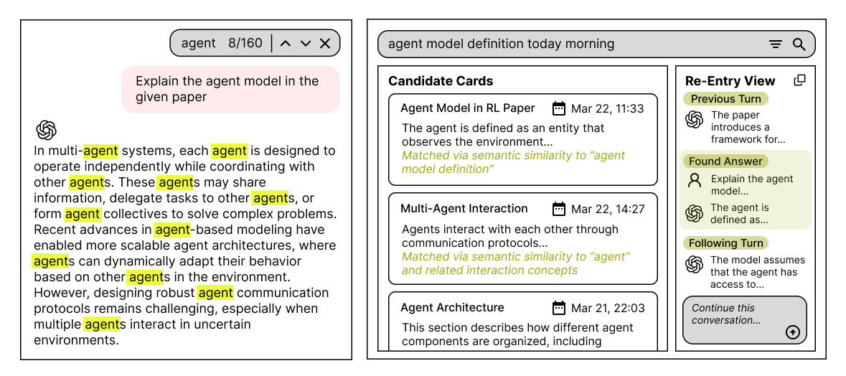
Figure 5. Hybrid interface concept for context-rich re-entry to past AI responses.

First, the starting point of the search is changed from exact keyword input to ambiguous natural language input. This addresses the common limitation of restricted search scope identified in Section 1.2.2. Additionally, filters such as date range, task type (e.g., coding question, topic-specific research, learning), and output type (e.g., table, visualization, document, code) are provided to reduce recall burden. Alternatively, the keywords most frequently entered by the user over the past 1-2 weeks could be suggested at the top of the screen ranked by frequency to reduce recall burden. Second, results are displayed not as full-session text retrieval but in segment units, each presented as an individual card. Third, since users need not merely access past answers but also understand the context of those answers for reuse, visual patterns that support this are provided. This retrieval journey aligns with points emphasized in prior research. Finally, if the user’s natural language query is too ambiguous, the system poses clarifying sub-questions rather than immediately presenting an answer. These are predefined auxiliary questions that stimulate the user’s memory, such as task type, output type, date, and time period. This is an interaction that helps reveal the user’s partial memory rather than immediately processing an ambiguous request as a keyword search.

3.4. System Architecture
- Cue input: Natural language memory cues, date filter, task type filter, output type filter.
- Candidate cards: Date, short topic summary, code/table/chart preview, contextual explanation of why this result was retrieved.
- Re-Entry view: The user’s original question, the found answer, subsequent follow-up questions, related segments, and additional features such as copy and bookmark.
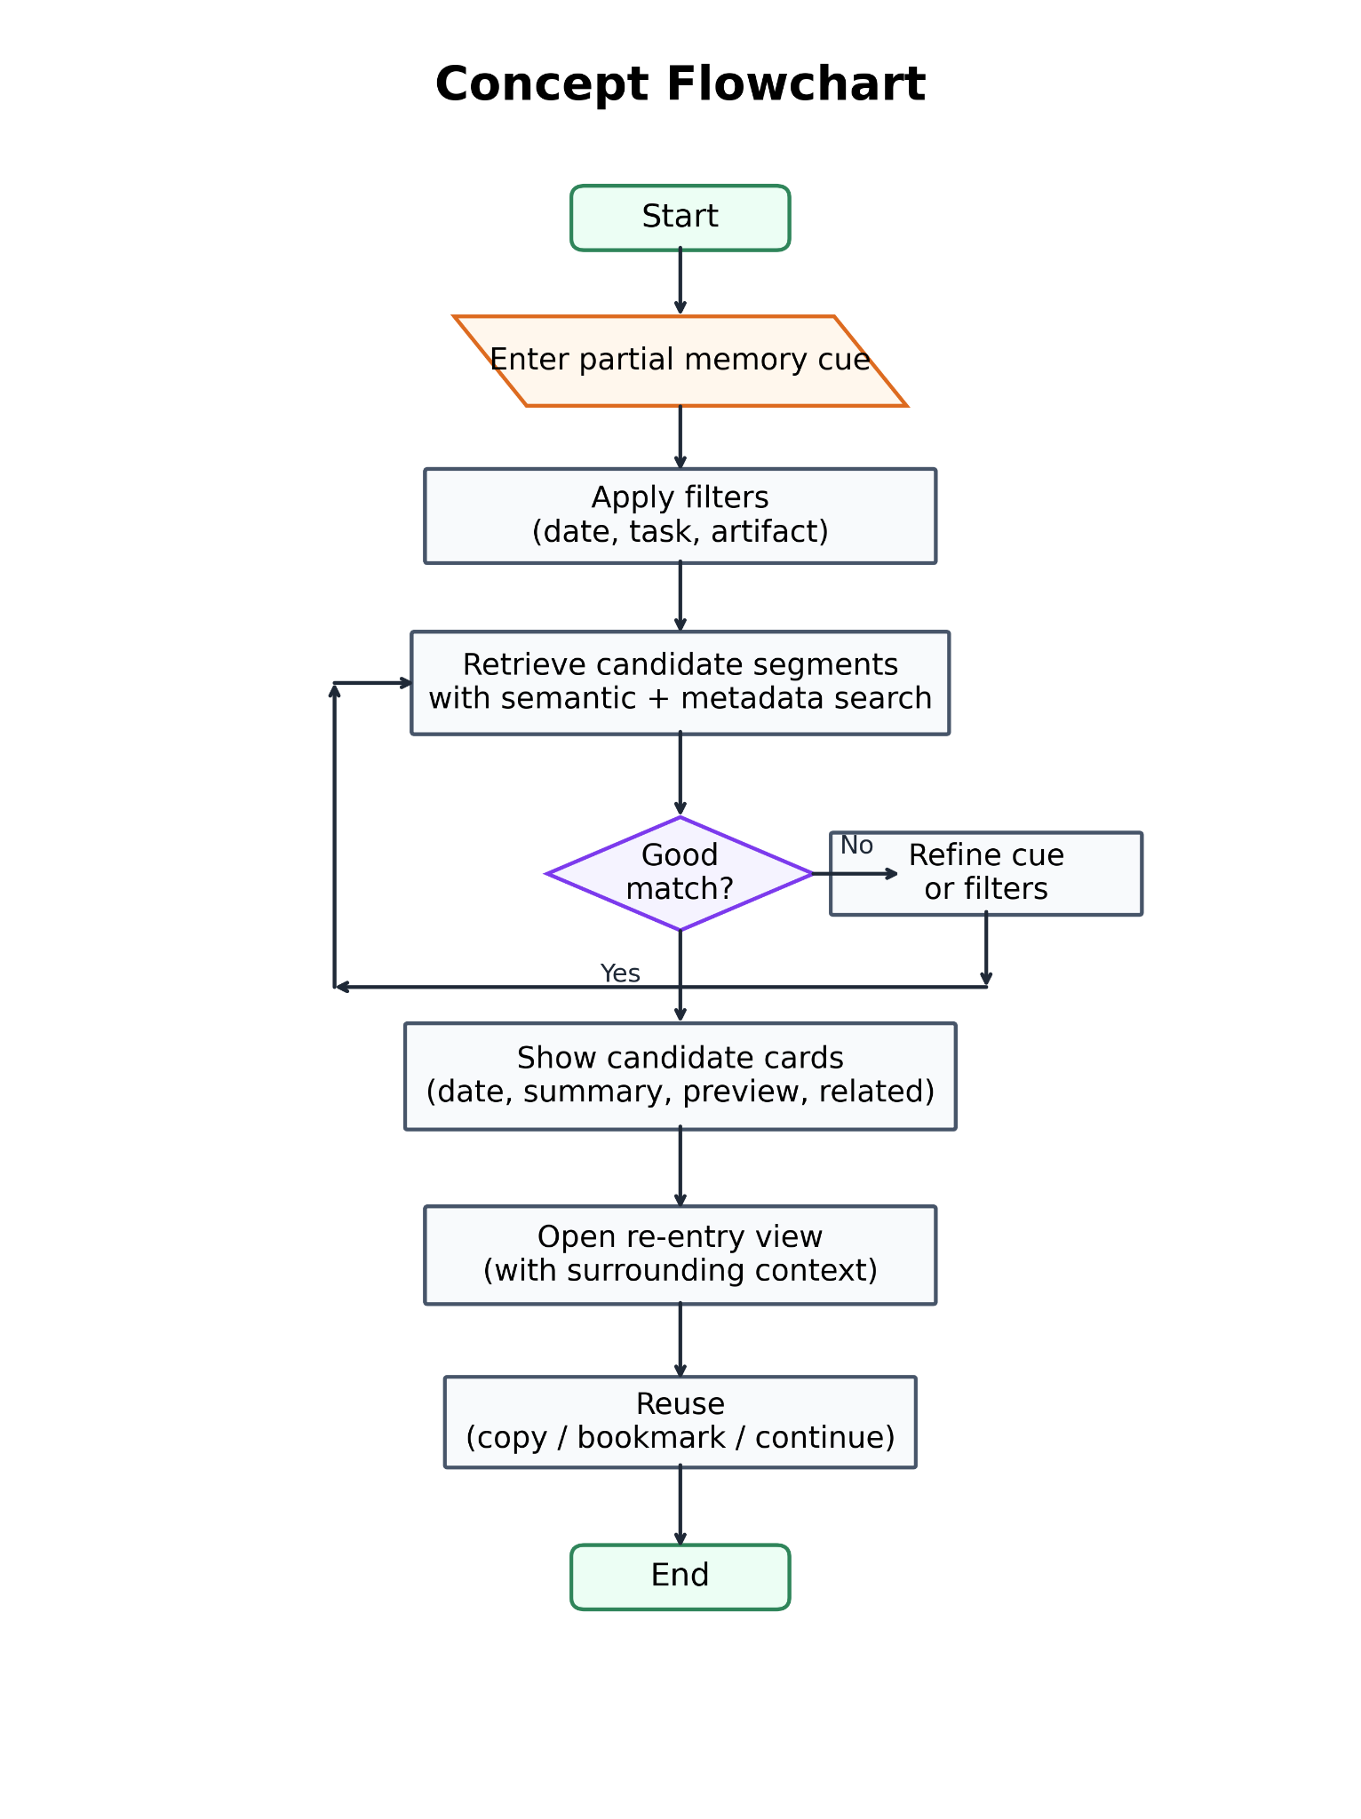
Figure 6. System flow of the proposed hybrid re-entry interface.

3.5. Necessary Information
- Data: Raw conversation text, timestamps, session/thread unique IDs, user/assistant role distinction, generated outputs, file format classification of user-attached attachments.
- AI-extracted information: Context, topic transition points (i.e., segment boundaries), per-segment summaries, task type tags, output type tags, semantic embeddings, adjacent segments.
- UI elements: Conversation date, timeline, immediately preceding question, immediately following question, brief explanation of why results were retrieved as such, reuse/follow-up action buttons (e.g., save, bookmark).

4. EVALUATION PLAN

4.1. User Study Methodology
Prior to conducting the experiment, we will provide a detailed explanation of the study’s purpose and procedures, and the experiment will be carried out only after obtaining informed consent from all participants regarding data collection and usage.
The target participant pool consists of graduate students/researchers who use conversational AI (e.g., ChatGPT, Claude, Gemini) for more than 2 hours per day and have experience attempting to re-find past conversations. These criteria will be used to pre-screen and recruit 10 KAIST graduate students as participants. The user study adopts a within-subjects design, where all participants experience both the baseline and prototype conditions. To control for order effects, a counterbalancing design is applied: half of the participants proceed in the baseline then prototype order, and the other half in the prototype then baseline order.
A designated period before the main experiment session, participants interact with a conversational AI tool (e.g., ChatGPT) to complete a set of predefined task scenarios (e.g., writing code for data analysis, summarizing a paper). The tasks are designed to produce conversations that span multiple topics and elicit responses in diverse formats, including code, tables, and images. The length of this interval will be determined through pilot testing to ensure that memory for specific wording decays while gist-level memory of topics is retained (Kintsch et al., 1990).
Participants then perform search tasks in which they are asked to find the answer to given search questions. Specifically, the provided questions are categorized into two types according to the cognitive search mode classification described in Section 1.2.1. First, teleporting-type questions provide relatively specific cues, for example: “There was code in this conversation for merging pandas DataFrames; please find that part.” These assume a situation where the user retains memory of a specific keyword or output. Second, orienteering-type questions provide only vague contextual cues, for example: “Around the middle of the conversation, there was a discussion about experimental design and a table appeared; please find that part.” These reflect situations where users must search with only temporal and topical cues without exact keywords. We will set a predefined time limit for each task, and classify it as a failure if the target response is not achieved within that limit. Finally, after each session concludes, cognitive load and subjective satisfaction are measured.
Experiments will be conducted in meeting rooms or soundproof labs. Behavioral data will be collected using computers/laptops, and after each condition concludes, subjective satisfaction, cognitive load measurements, and semi-structured post-interviews will be conducted.

4.2. Evaluation Criteria & Data Collection
The evaluation is organized along three axes: efficiency, effectiveness, and satisfaction. These axes correspond directly to the three design goals presented in Section 3.1: reducing exact recall burden, supporting cue-based retrieval, and minimizing attention residue. The specific criteria and data to be collected are as follows.
A. Efficiency (Search Cost)
The temporal and behavioral costs incurred during the re-finding process are measured. This relates to the design goal of reducing attention residue: the lower the cost of re-finding, the faster users can return to their original task.
- Task completion time: The elapsed time from when the search question is presented to when the participant reaches the target segment.
- Number of search attempts: The total number of times the participant enters a query or modifies a filter. Fewer attempts suggest lower recall burden.
- Scroll/click count: The frequency of physical navigation actions during the search process.
B. Effectiveness (Search Accuracy)
This evaluates whether the participant reached the correct answer and whether they accurately reconstructed the context of that answer. This is the key metric for verifying the effectiveness of cue-supported retrieval.
- Task success rate: The proportion of tasks in which the correct segment was found within the given time.
- Context reconstruction accuracy: After participants find the target segment, they are asked to briefly describe the original question and the surrounding context, which is then scored (0: inaccurate, 1: partially accurate, 2: accurate). This assesses whether contextual understanding is supported beyond mere location finding.
C. Satisfaction (Subjective Experience)
The cognitive load perceived by participants and their overall user experience are measured. Data is collected and evaluated through cognitive load measurement and semi-structured interviews.
- NASA-TLX: The 6 sub-dimensions are measured immediately after each condition. The Mental Demand and Frustration items in particular directly correspond to the project’s core hypotheses (i.e., reducing exact recall burden and cognitive friction).
- 7-point Likert scale items: The following items are added to evaluate the project-specific design goals: (a) ‘I was able to find the desired answer even when exact keywords did not come to mind.’ (recall burden), (b) ‘The search results were helpful in understanding the context I was looking for.’ (cue-supported retrieval), (c) ‘The process of finding past answers did not significantly disrupt my current workflow.’ (attention residue).
- Between-condition preference: In the post-interview, participants are asked to directly compare the two conditions and the reasons are collected.
Quantitative data will be compared between conditions using paired-samples t-tests or Wilcoxon signed-rank tests. Effect differences by task type (i.e., teleporting vs. orienteering) will be additionally analyzed to determine in which search mode the prototype is particularly effective. Interviews will be analyzed using thematic analysis (Braun & Clarke, 2006) to identify key themes regarding differences in search strategies and user experience between the two conditions.

5. IMPLEMENTATION AND TIMELINE

5.1. 12-Week Project Timeline
The project will be conducted according to the 12-week timeline presented in Table 2 below.
Table 2. Expected Project Timeline
Week | Goal
1-2 | User Analysis
3-5 | Prototype Design & Development
6 | Pilot Study (Task Validation & Usability Check)
7-8 | User Study
9-10 | Data Analysis
11 | Design Iteration & Implications
12 | Writing Final Report

5.2. Tools and Software

The following tools and software will be used throughout the project to support prototyping, user studies, data analysis, and project management.

Prototype implementation: Figma (design) + React (front-end) + FastAPI (back-end), vibe coding tools such as Cursor and Claude Code

User study: Screen recording tools (e.g., Zoom, OBS)

Data analysis: Statistical analysis software (e.g., R, Python)

Project and version management: Collaboration tools for smooth project progress (e.g., GitHub, Notion)

6. EXPECTED CONTRIBUTION
The expected contributions of this project can be divided into two aspects.
1) Design Contribution
This project proposes a hybrid interaction method for information re-finding within conversational AI interfaces. Specifically, we aim to design a three-stage re-finding interaction consisting of: cue input combining ambiguous natural language input with metadata filters, candidate cards with visualized conversational context, and a re-entry view that enables answer reuse within the original conversation flow.
This serves as a design alternative to the structural limitations of current interfaces that rely on keyword-based search and simple chronological listing, and can provide concrete design patterns and principles for the future design of search and navigation features in conversational AI services.
2) Empirical Contribution
Through a within-subjects experiment, we can provide empirical evidence on whether recognition-oriented cues (e.g., visual contextual cues, filters, summary cards) actually reduce users’ exact recall burden. In particular, by analyzing the prototype’s effectiveness across the two search modes of teleporting and orienteering, we can identify in which cognitive state context-based re-finding support is most effective. Furthermore, through reductions in the temporal and behavioral costs of the re-finding process (e.g., task completion time, number of search attempts), we can verify whether attention residue is actually mitigated.
The proposed solution can be applied on top of existing conversational AI interfaces and is significant in that it can address usability issues experienced by heavy users without requiring a complete redesign of the service.

REFERENCES
Braun, V., & Clarke, V. (2006). Using thematic analysis in psychology. Qualitative research in psychology, 3(2), 77-101.
Brown, R., & McNeill, D. (1966). The “tip of the tongue” phenomenon. Journal of verbal learning and verbal behavior, 5(4), 325-337.
Dumais, S., Cutrell, E., Cadiz, J. J., Jancke, G., Sarin, R., & Robbins, D. C. (2003, July). Stuff I've seen: a system for personal information retrieval and re-use. In Proceedings of the 26th annual international ACM SIGIR conference on Research and development in information retrieval (pp. 72-79).
Elsweiler, D., Ruthven, I., & Jones, C. (2007). Towards memory supporting personal information management tools. Journal of the American Society for Information Science and Technology, 58(7), 924-946.
Gu, K., Palani, S., & Setlur, V. (2026). "I Need to Find That One Chart": How Data Workers Navigate, Make Sense of, and Communicate Analytical Conversations. arXiv preprint arXiv:2603.00485.
Hangal, S., Lam, M. S., & Heer, J. (2011). Muse: Reviving memories using email archives. In Proceedings of the 24th annual ACM symposium on User interface software and technology (pp. 75-84).
He, Y., Kim, T. E., Diaz, F., Arguello, J., & Mitra, B. (2025). Tip of the tongue query elicitation for simulated evaluation. In Proceedings of the 48th International ACM SIGIR Conference on Research and Development in Information Retrieval (pp. 3398-3407).
Kintsch, W., Welsch, D., Schmalhofer, F., & Zimny, S. (1990). Sentence memory: A theoretical analysis. Journal of Memory and language, 29(2), 133-159.
Leroy, S. (2009). Why is it so hard to do my work? The challenge of attention residue when switching between work tasks. Organizational Behavior and Human Decision Processes, 109(2), 168-181.
Mandler, G. (1980). Recognizing: The judgment of previous occurrence. Psychological Review, 87(3), 252–271. https://doi.org/10.1037/0033-295X.87.3.252
Tulving, E., & Thomson, D. M. (1973). Encoding specificity and retrieval processes in episodic memory. Psychological Review, 80(5), 352–373.
Teevan, J., Alvarado, C., Ackerman, M. S., & Karger, D. R. (2004). The perfect search engine is not enough: a study of orienteering behavior in directed search. In Proceedings of the SIGCHI conference on Human factors in computing systems (pp. 415-422).
Rachatasumrit, N., Ramos, G., Suh, J., Ng, R., & Meek, C. (2021). Forsense: Accelerating online research through sensemaking integration and machine research support. In Proceedings of the 26th International Conference on Intelligent User Interfaces (pp. 608-618).
Viégas, F. B., Golder, S., & Donath, J. (2006). Visualizing email content: portraying relationships from conversational histories. In Proceedings of the SIGCHI conference on Human Factors in computing systems (pp. 979-988).
Yen, R., & Zhao, J. (2024). Memolet: Reifying the reuse of user-ai conversational memories. In Proceedings of the 37th Annual ACM Symposium on User Interface Software and Technology (pp. 1-22).

